SWA Inline 2.0 AB test result Update as of 2017-12-14:

The Test through the flash promo between Dec 1st and Dec 11th. Inline 2.0 generated -17% lower Revenue per Visitor due to lower ATS.

1. The Revenue per Visitor of Inline 2.0 is **-17% lower** than the Control Storefront.
2. The conversion rate of the Test Storefront was **-5% lower** than that of the Control Storefront
3. The ATS of the Test Storefront was **-16% lower** than that of the Control Storefront.
4. The Estimated Revenue deficit per day is $5,500

You can find the report here,

<https://data.points.com/#/views/SWA_Inline2_0_Nov2017_ABTest_FlashPromo/Story>

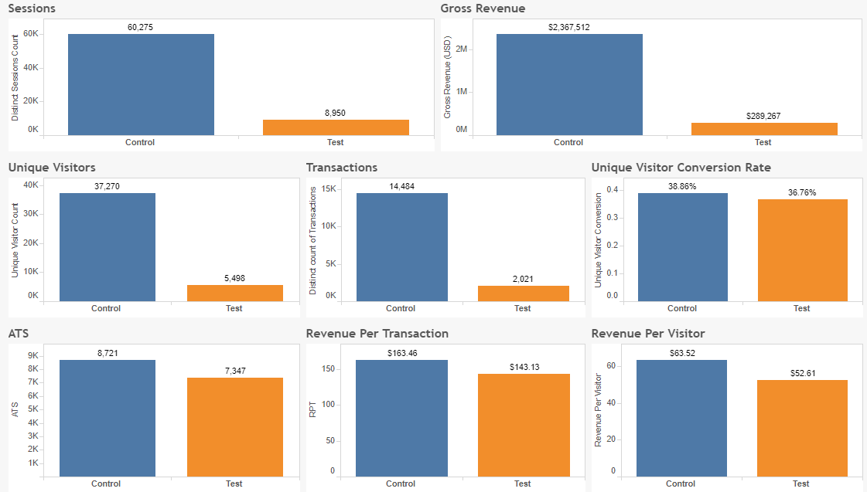

The test ran for two days during baseline on December 12th and 13th; Inline 2.0 generated **+10%** higher Revenue per Visitor. The conversion was **+14%** higher for Inline 2.0.

